Overview  Country: United States  Industry: Financial Services  Customer Profile  Founded in 1914 and based in Northern California, California Casualty Management Company pioneered the concept of group automobile and home insurance in 1951 and now serves more than 100 educator and public-safety associations in 24 states. California Casualty employs 900 and in 2002 had 290,000 policies in force.  Business Situation  Reduced investment income required California Casualty to cut the cost of managing information technology (IT) projects, which constitute a significant expense for this information-intensive company. But the solution in place, an internally developed time-entry system, was unable to capture task activity at the necessary level of detail.  Solution  California Casualty is deploying the Microsoft® Office Enterprise Project Management Solution, first in the IT department and then throughout the enterprise. Project partners are AstroWix Corporation, a Microsoft Certified Partner, and New Horizons Computer Learning Centers, a Microsoft Certified Technical Education Center.  Benefits  - Increased productivity, thanks to improved collaboration enabled by centralized document storage and access  - Simplified approach to growth through extensibility and scalability  - Enhanced visibility of IT resources and allocations to control costs and deploy resources for maximum profitability |  |  | “Looking at its enhanced support for collaboration, scalability, and extensibility through integration with other server and desktop applications, we easily saw the Microsoft Office Enterprise Project Management Solution as an enterprise-level project management solution.”  Tom Grisell, Network Development Manager, California Casualty Management Company
California Casualty Management Company is a family-owned business established in 1914 and known for pioneering the concept of group automobile and home insurance. To address the challenge of reduced investment revenue in a long-running bear market, the company is seeking to cut IT costs with the help of an enterprise-level project management system. With support for collaboration, scalability, and extensibility as key criteria, the company selected the Microsoft Office Enterprise Project Management Solution.

Executives anticipate that when the deployment is complete, they will gain an enhanced ability to deploy resources for maximum profitability, to control ongoing project costs, and to more accurately estimate the cost of future projects.

 |  |  | 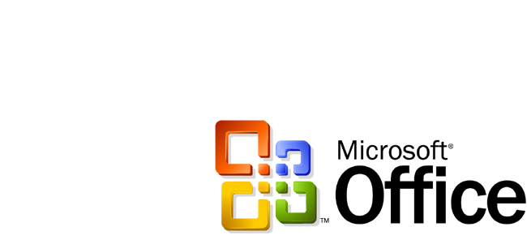

Situation
The bear market and unpredictable economic climate of recent years have posed significant challenges to companies in industries that rely heavily on investment income to remain profitable. Insurance providers constitute a case in point. For them, the challenge is to cut costs without sacrificing customer service. Because of the information-intensive nature of the business, information technology (IT) expenditures are a key target of cost-cutting efforts.

One example is California Casualty Management Company, a Northern California business specializing in group automobile and home insurance for educator and public-safety associations. At California Casualty, IT costs represent roughly 6 cents of every dollar of policyholder premiums.

"This is in line with the benchmark for direct-writer, affinity-group marketer companies," according to Beau Brown, Senior Vice President, Strategic Planning and Technology. "But it's still a significant expense, which makes it imperative that IT professionals have the management tools that they need to do their jobs efficiently and cost-effectively."

In the past, the California Casualty IT Network Services department approached project management in an ad hoc fashion, using various applications at the desktop level and an internally developed, server-based time-entry system. That system was lacking in several respects, according to Network Development Manager Tom Grisell—not the least of which was its inability to capture task activity at the necessary level of detail.

"The time-entry system defined allocations at a functional level, such as ‘support' or ‘administration,' but we needed allocations defined at the task level so we could know where people really spent their time," Grisell says. "That's the only way to effectively track success, failure, delays, budget concerns, and the like. We also needed to be able to roll up reports and status updates for making executive-level decisions about resource allocation."

Making those decisions in a timely manner, while projects were ongoing, was an even more pressing challenge.

"The time-entry system wasn't able to provide real-time information to all the people who needed it, so we often had to rely on weekly meetings," Grisell says. "But by the time the meeting was held, the information might well have been outdated, which seriously affected the quality of decisions made. We needed tools that would enable us to shift resources or otherwise change course when a project was, say, 5 percent over budget rather than waiting until it was 40 percent over budget."

Solution
For Brown and his colleagues, having the proper tools meant implementing an enterprise project management solution that would provide enhanced visibility and control to IT managers and team members, simplify reporting and analysis, streamline collaboration and communication throughout all levels of the department, and introduce a more structured approach to the overall process of project management.

To meet these goals, Brown, Grisell, and their colleagues decided to implement the Microsoft® Office Enterprise Project Management (EPM) Solution. Grisell cites two primary reasons for choosing a Microsoft-based approach to the challenge.

One, the department and company already had a close working relationship with Microsoft and were successfully using a number of Microsoft server and desktop products. Two, the team liked the capabilities of the Microsoft Office EPM Solution, including its enterprise resource database, its enhanced support for team building, and its Web-based interface.
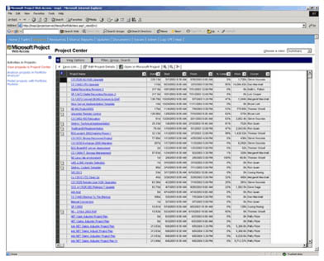

Grisell summarizes: "Looking at its enhanced support for collaboration, scalability, and extensibility through integration with other server and desktop applications, we easily saw the Microsoft Office Enterprise Project Management Solution as an enterprise-level project management solution."

To prepare the company for deployment, Grisell and his colleagues assembled a team of seven people drawn from the IT and education development services departments. This team was charged with reviewing deployment progress; recommending enhancements, modifications, infrastructure adjustments, and training ideas; and developing standardized project templates.

In all, the team spent nearly a month in planning and preparation before the solution was built, which itself took a little over two months, and three months in preparing the workforce to use it. Thus, from inception of the solution to full user engagement took about six months.

Also in preparation for deployment, California Casualty engaged two California-based partners: AstroWix Corporation, a leading project management consulting company and Microsoft Certified Partner, and New Horizons Computer Learning Centers, the world's largest independent IT training organization and a Microsoft Certified Technical Education Center.
Initial view of the Microsoft Office EPM Solution for users accessing the solution through the Web
AstroWix assisted California Casualty with planning, customization, server configuration, and Project Management Institute (PMI) Certified Training for roles including server administrator, manager, team member, and executive.

"In our experience, these activities are crucial for any enterprise undertaking an EPM deployment," says Upendra Giri, PMP, Founder and CEO of AstroWix Corporation. "That's why we paid special attention to ensuring they were executed carefully and comprehensively for the California Casualty deployment."

New Horizons provided training in the Microsoft Office EPM Solution and in PMI to internal trainers and users.
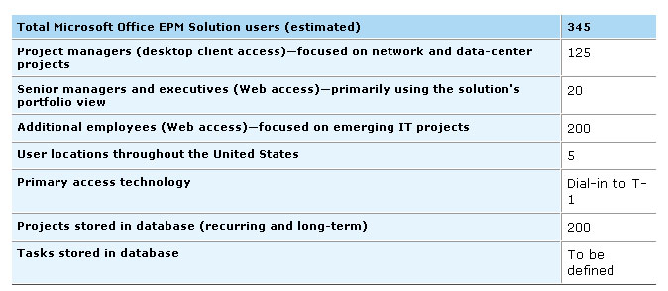
Table 1: Scope of use of the Microsoft Office EPM Solution once it is in full production

"Rarely does an enterprise have the expertise in any given software to undertake training internally," says Account Manager Daniel Burns. "So we were happy to step in and share our knowledge of the Microsoft Office Enterprise Project Management Solution and PMI in a way that would expedite the deployment at California Casualty."

Once the Microsoft Office EPM Solution is fully implemented in the California Casualty IT Network Services department, it will be deployed throughout the enterprise. At that point, the company will likely expand the use of its current solution beyond scheduling and resource allocation and into risk management and portfolio analysis.

Benefits
Enhancing Collaboration, Productivity with Centralized Document Storage
According to Grisell, the factors that led to his team's selection of the Microsoft Office EPM Solution—support for collaboration, scalability, and extensibility—are proving to be invaluable. Collaboration, for one, can be vastly enhanced through the centralized storage of vital project documents.

"Think of the time spent by one individual in e-mailing or phoning a request for a given document, and then waiting for the document to arrive, and then finding that it's out of date or otherwise not exactly what's needed so that the individual must repeat the process," Grisell says. "Then multiply that by the dozens of people involved in a given project, and multiple it again by all the documents any one of them may need to do his or her job. Now make it all go away by having these documents stored in a central location, accessible via a client- or browser-based interface, and automatically controlled for versioning. The productivity implications are enormous."

And those productivity implications extend well beyond the confines of a given project. "Even people not involved in a project can make use of the information being generated by those who are," Grisell points out. "For example, someone launching a project similar to another one that's ongoing or complete can learn from its mistakes and successes. People throughout the department can more easily become aware of what's going on outside their own projects. And people throughout the company can only stand to gain by the overall enhancement of knowledge sharing."

Extensibility and Scalability Supporting Growth
The extensibility and scalability of the Microsoft Office EPM Solution are additional advantages for Grisell and his colleagues. "Just having a solution based on the Microsoft server technologies such as Microsoft SQL ServerTM and Active Server Pages keeps the door open to all manner of extensions that we might find valuable in the future," he explains. "Just for starters, we could easily customize the Web interface to better suit our staff or build custom reporting using data stored in a Microsoft SQL Server database."

Scaling the Microsoft Office EPM Solution to address future growth also is enabled by the solution's foundation in the Microsoft server technologies. "We can start with a single server—as we have now—and scale out as needed, depending on growth in the number of users, projects, resources, and so on," Grisell says. "We also can scale out to accommodate geographic expansion or to address network-traffic problems by deploying additional servers at remote sites."

Making Effective Strategic Business Decisions, Controlling Costs
As a result of these advantages in collaboration, extensibility, and scalability, Grisell and his colleagues are confident the Microsoft Office EPM Solution will serve California Casualty well in helping to enhance insight into and control of key IT initiatives—positioning the company to make effective strategic business decisions in a challenging economic environment.

According to Brown, "By having a solution that enables a clear and comprehensive view of IT resources and where they are allocated, we'll not only control costs but also be able to deploy those resources into areas that will maximize profitability and service to our customers."

For example, since 2000, when the company received the endorsement of the National Education Association, California Casualty has been expanding coverage to schoolteachers nationwide—at the rate of three to six new states per year. "Such expansion requires a significant investment in IT resources for upgrading applications to accommodate diverse state regulations," Brown points out. "With a solid EPM solution in place, IT can be much more confident in committing to an aggressive rollout into new states."

More Accurate Estimates and Improved Efficiency Enterprisewide
By implementing a uniform approach to project management through the Microsoft Office EPM Solution's support of the PMI methodology, the company also will more easily accommodate future expansion of its staff. "For the first time, we'll follow standard processes and implement standard templates, reducing common errors and helping new team members to get up to speed as new projects are launched," Brown says.

Making smarter budgetary decisions is another anticipated advantage. "We'll be able to better gauge the cost of future projects by having an accurate picture of historical costs, based on consistent, standardized criteria and measurements," Brown points out. "Consequently, we expect to recoup our investment in the Microsoft Office Enterprise Project Management Solution in just a couple of years."

Looking at the long view, Brown explains that California Casualty will eventually move to replicate the advantages of the Microsoft Office EPM Solution beyond the IT department.

"In a recent employee survey, our employees indicated that planning for workgroup-level initiatives has been far more efficient than planning for initiatives at the companywide level," Brown says. "But I feel that if we can implement the Microsoft Office Enterprise Project Management Solution throughout the company, we can dramatically reduce the duration and better the outcomes of enterprisewide projects as a result of improved resource coordination and increased accountability for meeting deadlines. In other words, we'll bring workgroup-level efficiency—in both the planning and management of our projects—to the enterprise level. That's something I'm really looking forward to."

The Microsoft Office System
For More Information
For more information about Microsoft products and services, call the Microsoft Sales Information Center at (800) 426-9400. In Canada, call the Microsoft Canada Information Centre at (877) 568-2495. Customers who are deaf or hard-of-hearing can reach Microsoft text telephone (TTY/TDD) services at (800) 892-5234 in the United States or (905) 568-9641 in Canada. Outside the 50 United States and Canada, please contact your local Microsoft subsidiary. To access information using the World Wide Web, go to: www.microsoft.com

For more information about AstroWix Corporation products and services, or visit the Web site at: www.astrowix.com

For more information about New Horizons Computer Learning Centers products and services, or visit the Web site at: www.newhorizons.com

For more information about California Casualty Management Company products and services, or visit the Web site at: www.calcas.com

© 2003 Microsoft Corporation. All rights reserved. This case study is for informational purposes only. MICROSOFT MAKES NO WARRANTIES, EXPRESS OR IMPLIED, IN THIS SUMMARY. Microsoft, Outlook, SharePoint, and Windows are either registered trademarks or trademarks of Microsoft Corporation in the United States and/or other countries. The names of actual companies and products mentioned herein may be the trademarks of their respective owners.

Document published October 2003

Software and Services  Products  Active Server Pages  Microsoft Internet Explorer  Microsoft Office Enterprise Project Management Solution  Microsoft Project 2002  Microsoft SharePoint Portal Server 2001  Microsoft SQL Server 2000  Microsoft Windows 2000 Professional  Microsoft Windows 2000 Server  Hardware | Compaq DL380  Dell Optiplex  Partners  Microsoft Office 97  Microsoft Outlook® 98

Software and Services  Products  Active Server Pages  Microsoft Internet Explorer  Microsoft Office Enterprise Project Management Solution  Microsoft Project 2002  Microsoft SharePoint Portal Server 2001  Microsoft SQL Server 2000  Microsoft Windows 2000 Professional  Microsoft Windows 2000 Server  Hardware | Compaq DL380  Dell Optiplex  Partners  Microsoft Office 97  Microsoft Outlook® 98

 | Hardware  - Compaq DL380  - Dell Optiplex  Partners  - New Horizons Computer Learning Centers  - AstroWix Corporation
  Software and Services
  - Products
  - Microsoft Project 2002
  - Microsoft SharePoint Portal Server 2001
  - Microsoft SQL Server 2000
  - Microsoft Office 97
  - Microsoft Outlook® 98
  - Microsoft Internet Explorer Microsoft Windows 2000 Server
  - Solutions
  - Microsoft Solution for Enterprise Project Management
  - Technologies
  - Active Server Pages

Microsoft Office is the business world's chosen environment for information work that provides the software, servers, and services that help you succeed by transforming information into impact.

For more information about Microsoft Office System, go to:
www.microsoft.com/‌office

